1. Bar Chart – Quantity of Each Product
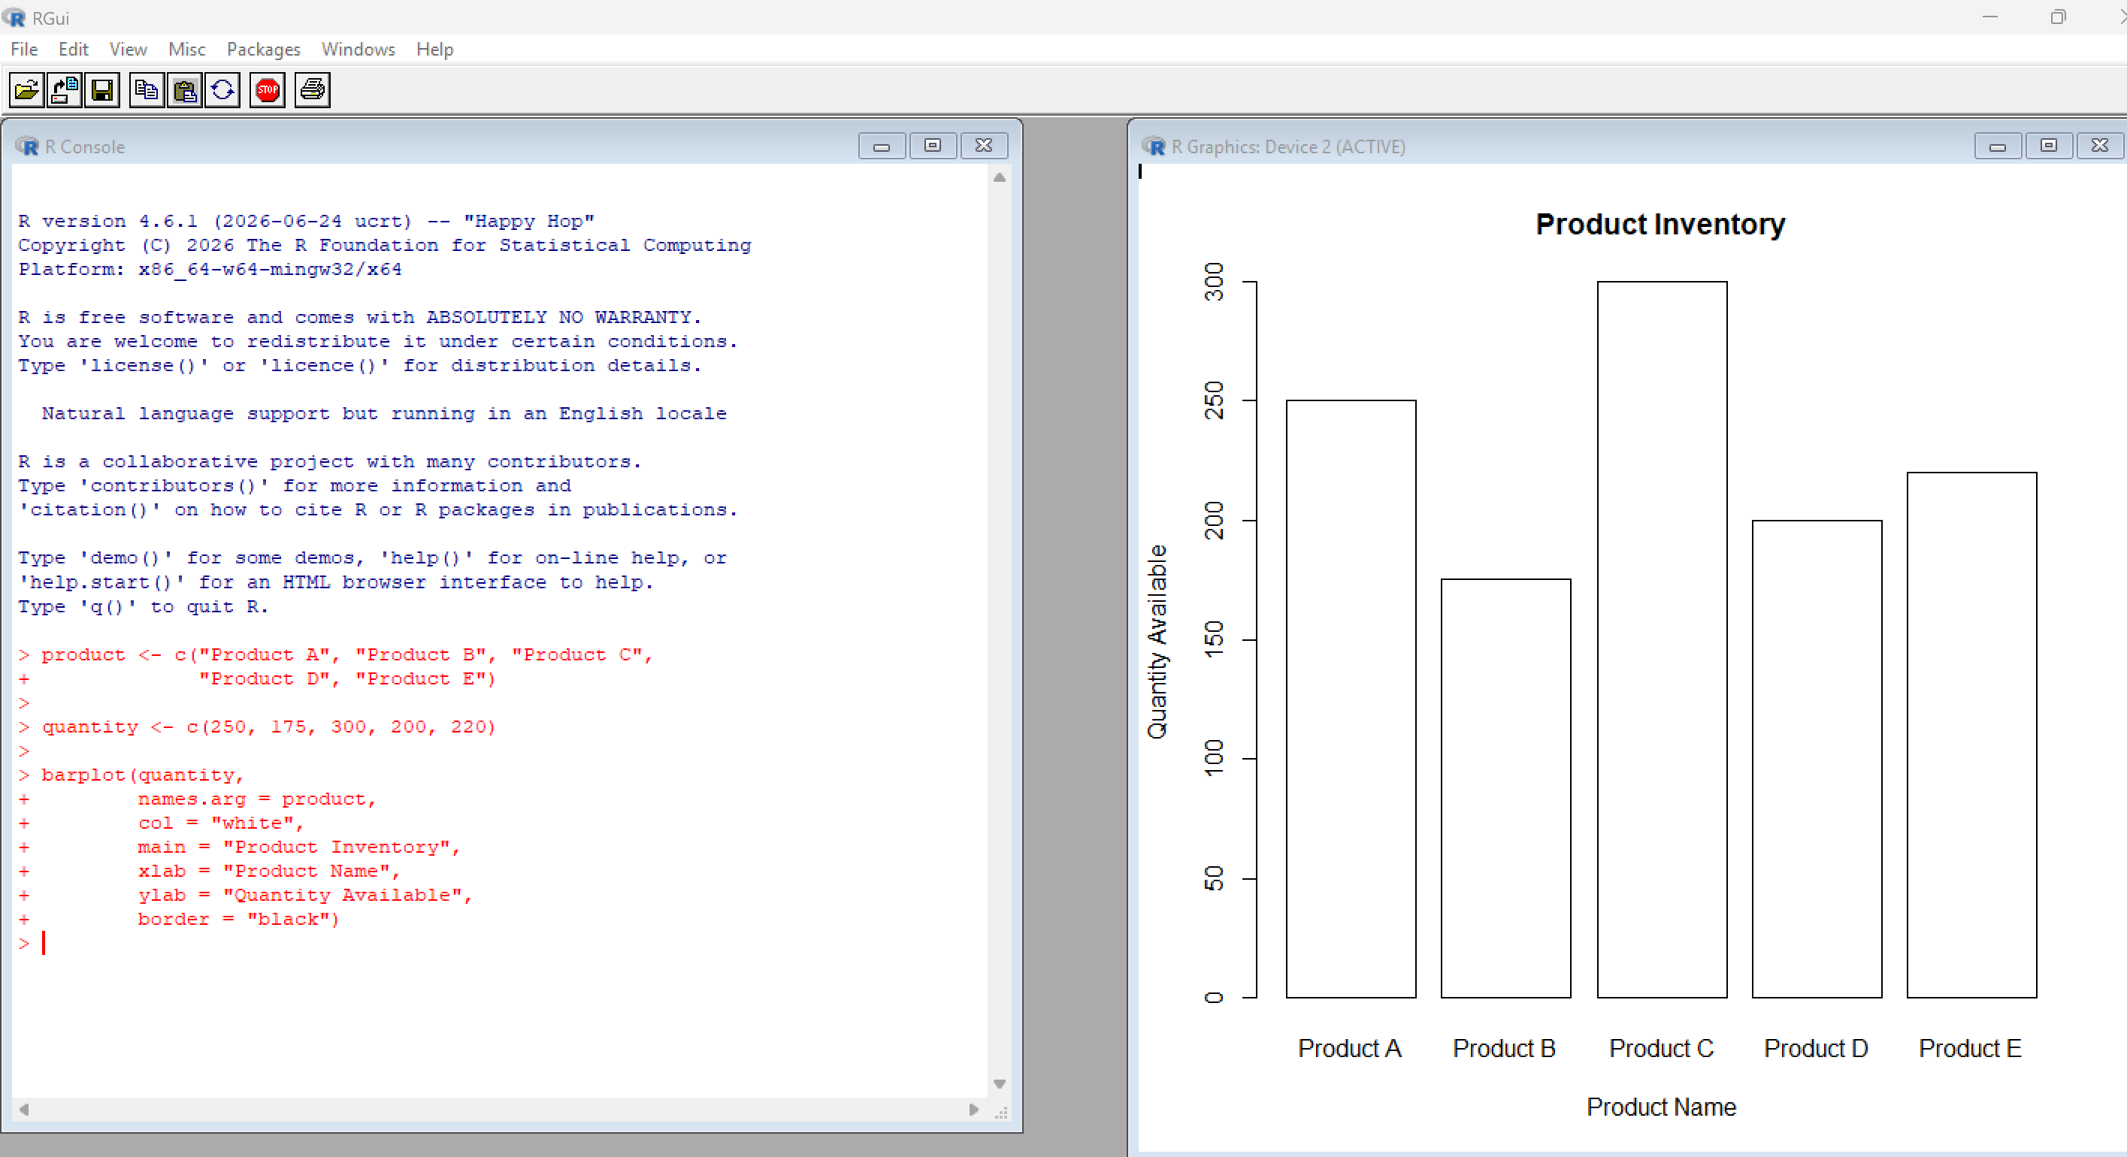

2. Stacked Bar Chart – Product Categories
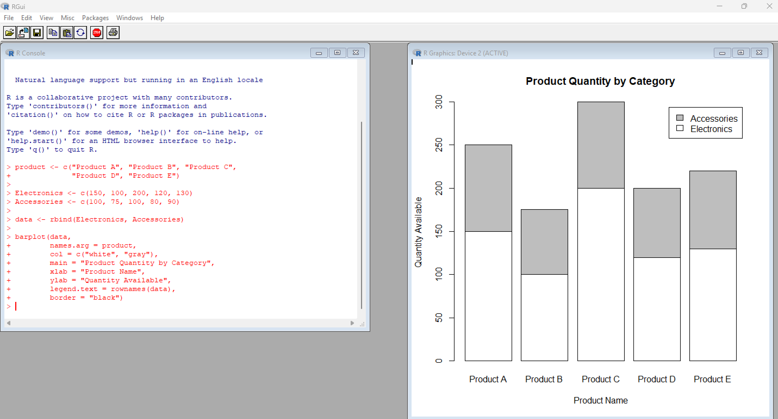

3. Scatter Plot – Product Price vs Quantity
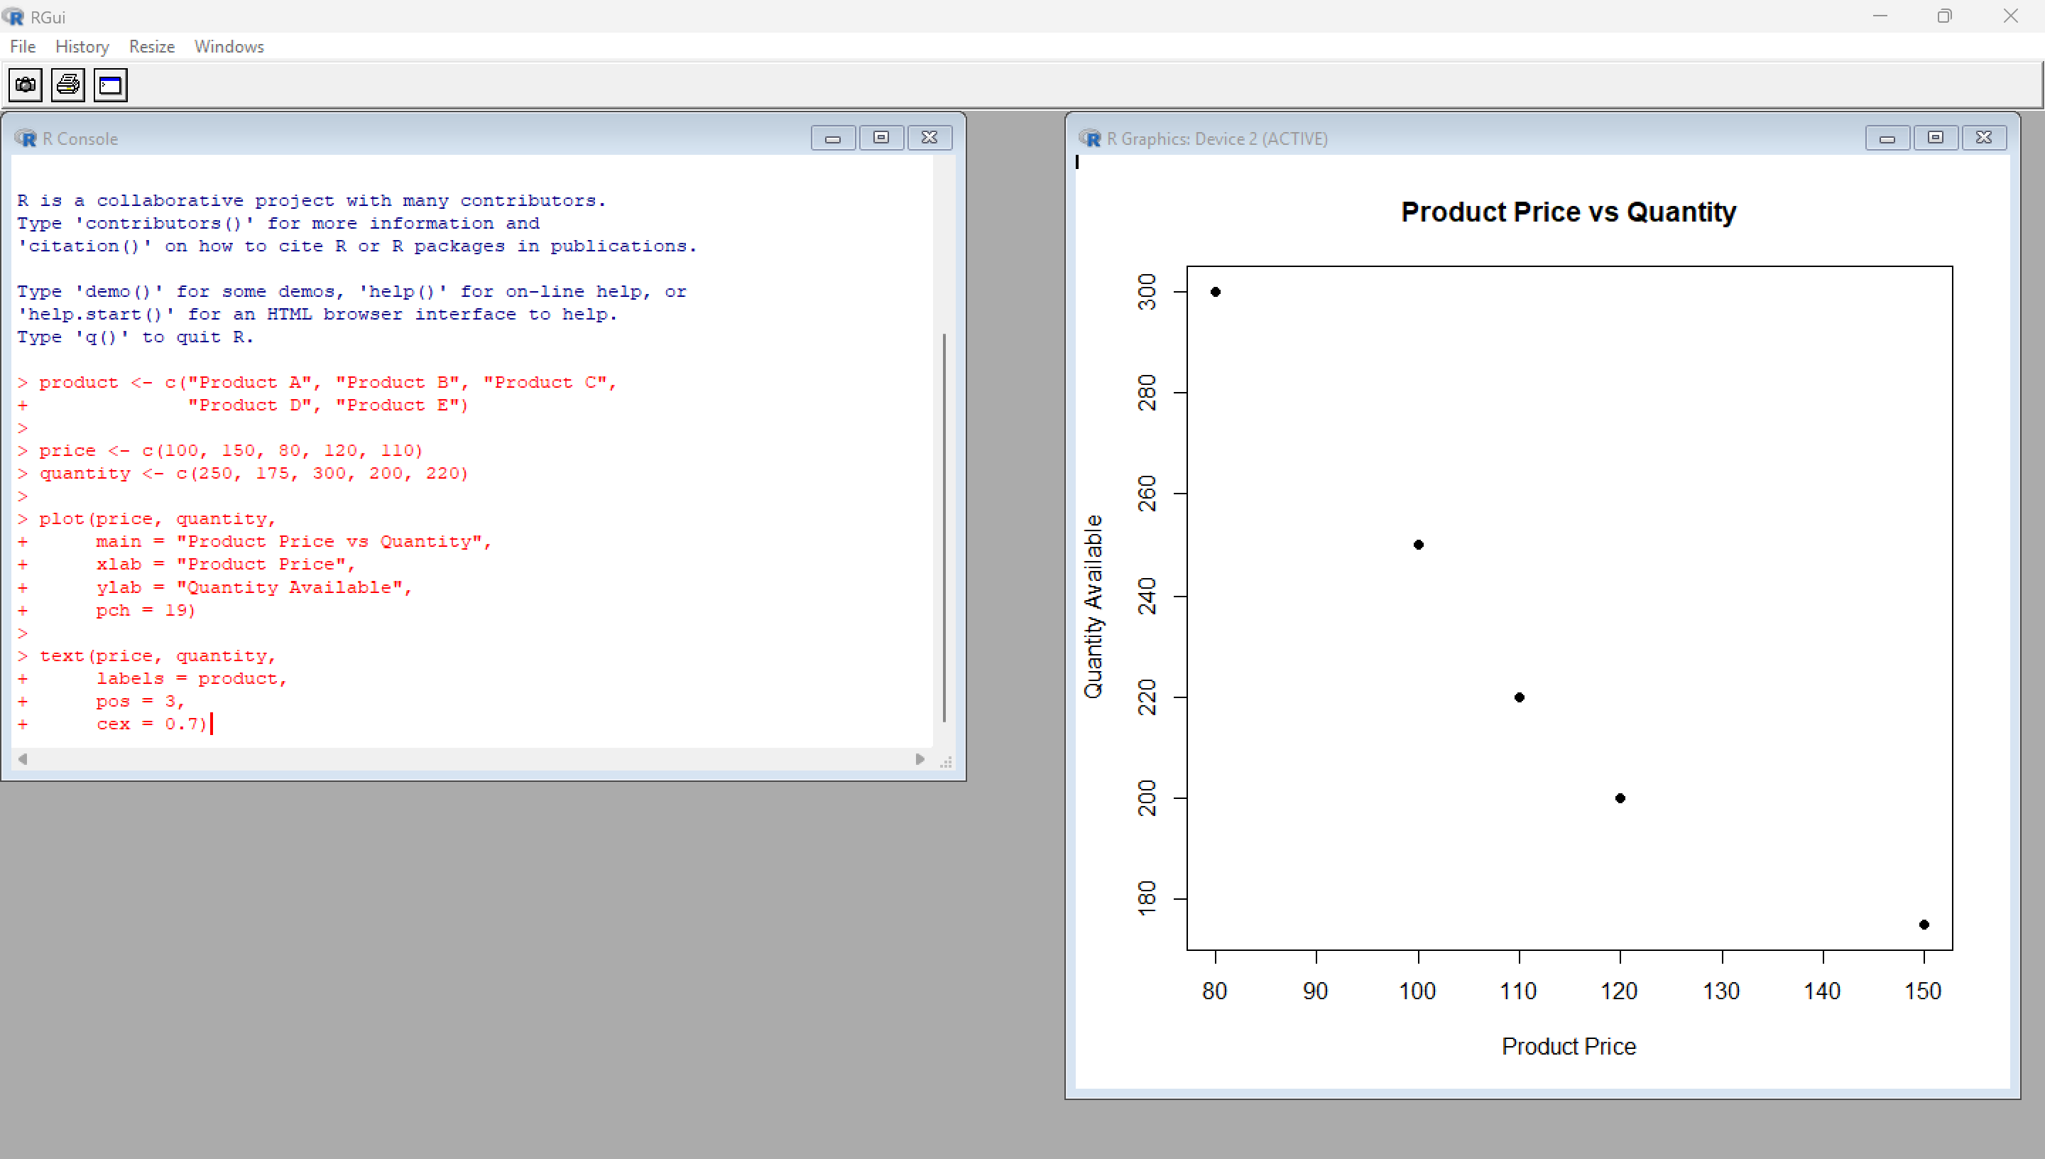

4. Tableau Dashboard – Bar Chart and Stacked Bar Chart
